RECENT NEWS FROM THE DOCTOR WHO NEWS PAGE.

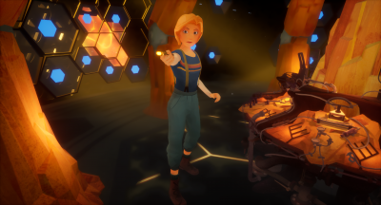
http://www.doctorwhonews.net/2019/02/doctor-who-virtual-reality-special.html
Doctor Who fans will soon be able to step inside a virtual reality version of the TARDIS, in a short VR film Doctor Who: The Runaway, coming soon from the BBC.
Jodie Whittaker reprises her role as the Doctor in animated form in the interactive story, which will run for around 12 minutes and will be available on selected VR headsets in the coming months. The film will feature music from the series composer Segun Akinola.
Viewers will join the Thirteenth Doctor on board the TARDIS in this animated interactive story from the BBC and Passion Animation Studios. Fans will get the chance to be the Doctor's champion and help her on this exciting adventure, as they find themselves at the centre of the action facing a deadly threat.
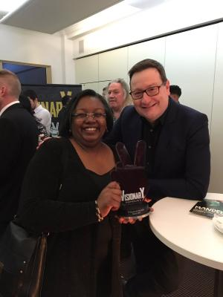
http://www.doctorwhonews.net/2019/02/rosa-wins-visionary-arts-award.html
The Doctor Who episode ‘ROSA’ has been awarded the Visionary Arts Organization Award for Television Show of the Year.
The new awards are given to celebrate culture, media and entertainment that have made a positive social impact via film, television, music, theatre, literature, radio/online and grassroots community.
‘ROSA’, the third Doctor Who episode starring Jodie Whittaker as the Thirteenth Doctor, featured Vinette Robinson as the American civil rights icon Rosa Parks, who changed history when she refused to relinquish her seat in the colored section of a bus to a white passenger.
The episode, written by Malorie Blackman and Chris Chibnall won plaudits on its transmission last October. The writers were there to accept the award this evening at a ceremony at BAFTA in London.
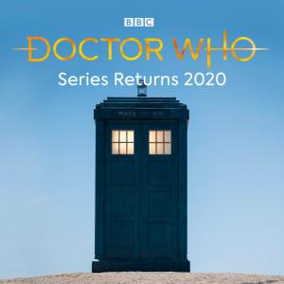
http://www.doctorwhonews.net/2018/12/no-series-2019-091218191508.html
The BBC confirmed this evening (12/9/18) that Doctor Who will not return for a full series next year, but will instead be back on air in early 2020.
Charlotte Moore, Director of BBC Content said:
“We’re delighted that the Doctor and her friends will be returning to thrill audiences in 2020. I know Chris and the whole team are already working on a whole new set of exciting adventures. In the meantime we’ve got a very special episode on New Year’s Day for everyone to enjoy.”
Current Showrunner for the series Chris Chibnall said: “We’re off again! Well we never actually stopped - as Jodie Whittaker’s Doctor and friends have been winning the hearts of families across the nation this autumn, we’ve been busy with a whole new set of action packed adventures for the Thirteenth Doctor. We adore making this show and have been blown away by the response from audiences, so we can’t wait to bring more scares, more monsters and more Bradley Walsh, Mandip Gill and Tosin Cole to BBC One. Brilliant!”

