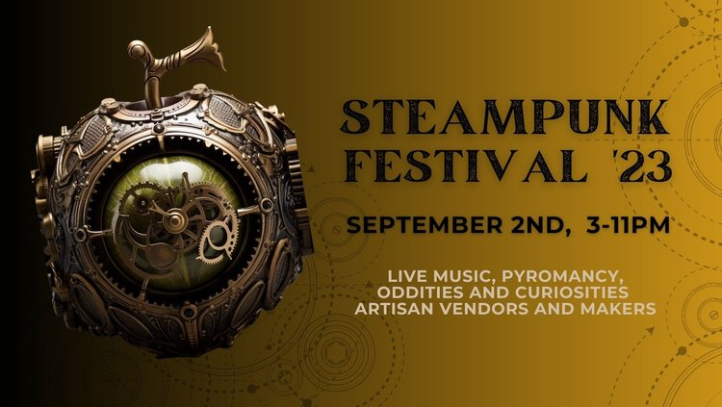
Steampunk Festival 2023
Saturday, September 2, 2023 3:00 PM - 11:00 PM
The return of our annual Steampunk Festival!
Live Music TBA
Oddities and Curiosities by Steampunk vendors, artisans, and makers
Fire performance by Pyromancy
Steampunk Costume Contest
Can't miss the festival of the year - tickets on sale now. $30 per person, children 12 and under free
Due to the capacity of our venue, we have a limited number of tickets available
for pre-purchase at the link below - get yours now!
https://www.oakeswinerylocal.com/
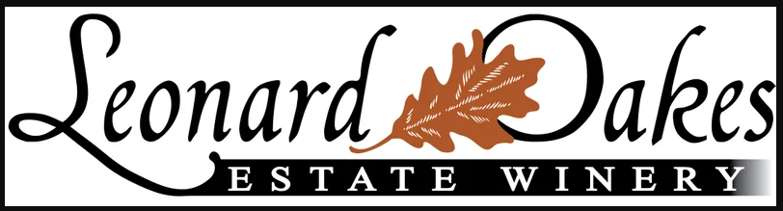
10609 Ridge Rd. Medina, NY 14103
585-318-4418 catherine@oakeswinery.com

